Django commands(brototype class-2)

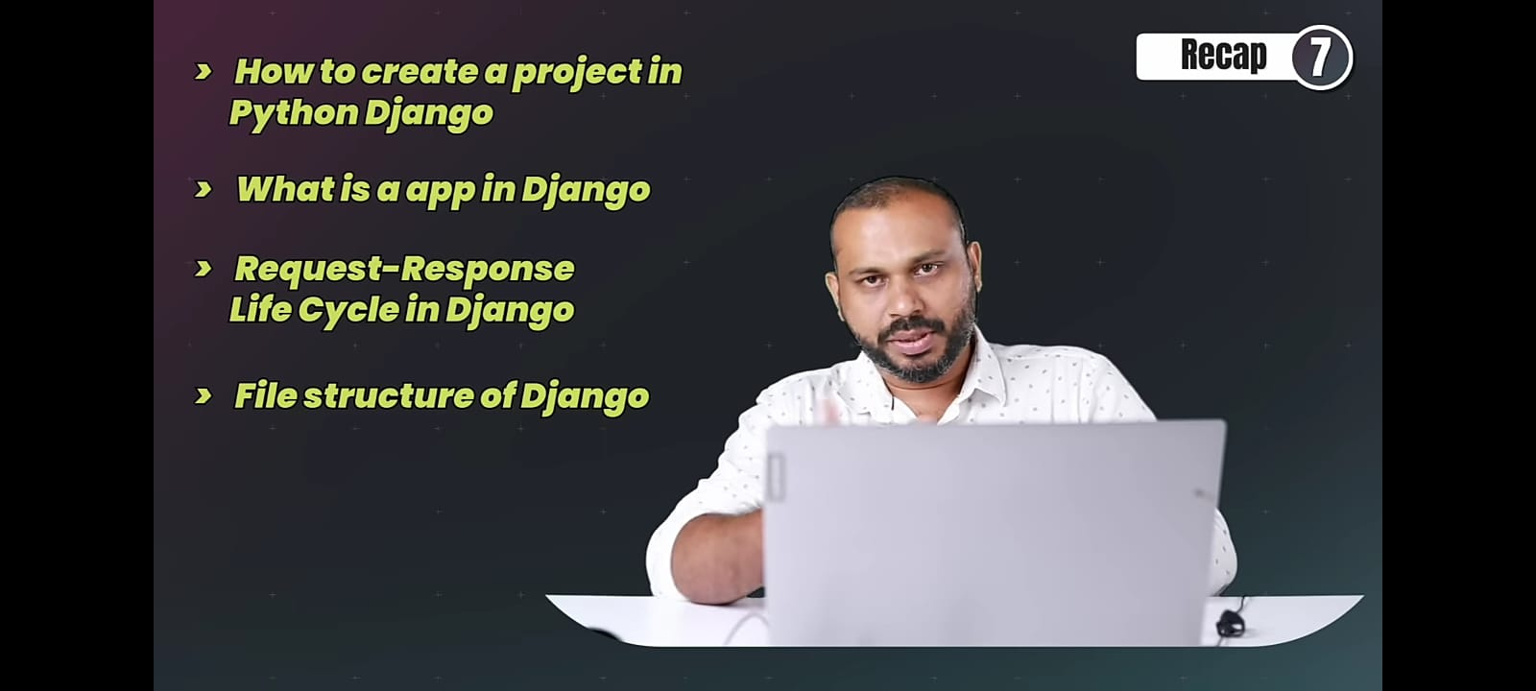

- virtualenv djanenv Creates a new isolated Python virtual environment named djanenv
- cd djanenv Moves into the virtual environment directory
- cd Scripts Navigates to the Scripts folder containing activation files (Windows)
- activate Activates the virtual environment
- pip install django Installs Django inside the virtual environment
- django-admin startproject hello_django Creates a new Django project named hello_django
- cd hello_django Enters the Django project directory
- python manage.py runserver Starts the Django development server
- python manage.py startapp hello_app Creates a new Django app named hello_app inside the project.
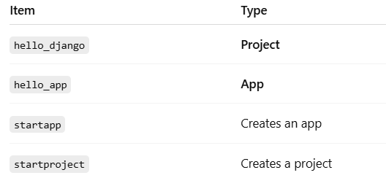

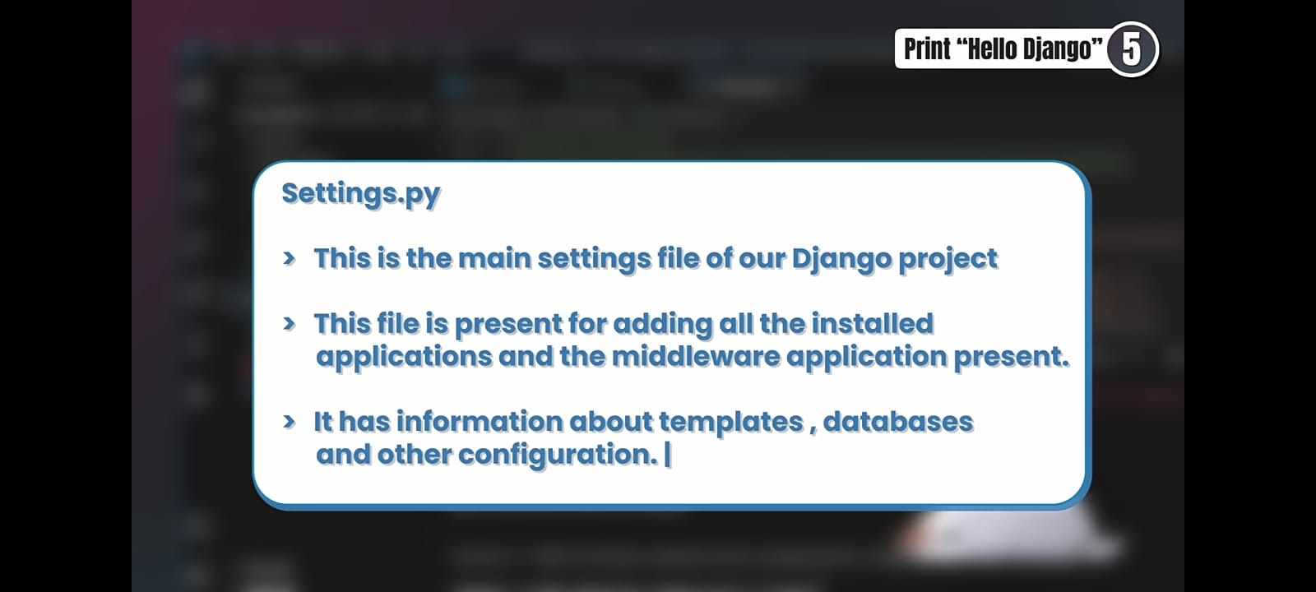
Created a view
- In hello_app/views.py, you defined print_hello() that returns
HttpResponse("hello django")
Added the app to settings
- In hello_django/settings.py, you added 'hello_app' to INSTALLED_APPS
Mapped the URL to the view
- In hello_django/urls.py, you connected /hello/ to views.print_hello
